ECE 0311.1 – Logic Circuits and Switching Theory (Laboratory)
FINAL PROJECT
A FULLY DISPLAY-INTEGRATED BCD ADDER: ADDING 0–9 + 0–9 WITH 7-SEGMENT INPUT AND OUTPUT DISPLAYS
1.0 THEORETICAL DISCUSSION
1.1 INTRODUCTION TO BINARY CODED DECIMAL (BCD)
Table 1: Standard 8421 BCD Code for Decimal Digits (0-9)
Decimal Number | BCD Code
0 | 0000
1 | 0001
2 | 0010
3 | 0011
4 | 0100
5 | 0101
6 | 0110
7 | 0111
8 | 1000
9 | 1001
10 | INVALID
11
12
13
14
15

Binary Coded Decimal (BCD) represents each decimal digit (0–9) using four binary bits. Unlike pure binary, which uses all 16 combinations (0000–1111), BCD only uses the first ten (0000–1001), making 1010–1111 invalid. BCD is useful because it directly maps to decimal digits, simplifying display and input handling in devices like calculators and digital clocks. However, it is less storage-efficient than pure binary. Proper handling of invalid codes is important when designing BCD-based circuits.
1.2 FUNDAMENTALS OF BCD ADDITION
BCD addition differs from binary addition because each digit must stay within 0000–1001. When the 4-bit sum exceeds 9 or produces a carry, the result becomes invalid, so a correction of +6 (0110) is added.
Examples:
- 3 + 4 = 7 → valid, no correction
- 5 + 6 = 11 → 1011 (invalid) → +6 → 10001 (BCD 11)
- 9 + 9 = 18 → 10010 (invalid) → +6 → 11000 (BCD 18)
The correction works because binary values 10–15 map to unused BCD codes, and shifting them into valid BCD form requires adding 6. Correction is triggered whenever the sum > 9 or when a carry is generated.
1.3 RIPPLE-CARRY 4-BIT FULL ADDER USING IC 7483
A full adder is a combinational logic circuit that adds three one-bit inputs—A, B, and the carry-in (Cin)—and produces a one-bit sum (S) and a one-bit carry-out (Cout). Its basic Boolean functions are:
- S = A ⊕ B ⊕ Cin
- Cout = (A·B) + (Cin·(A ⊕ B))
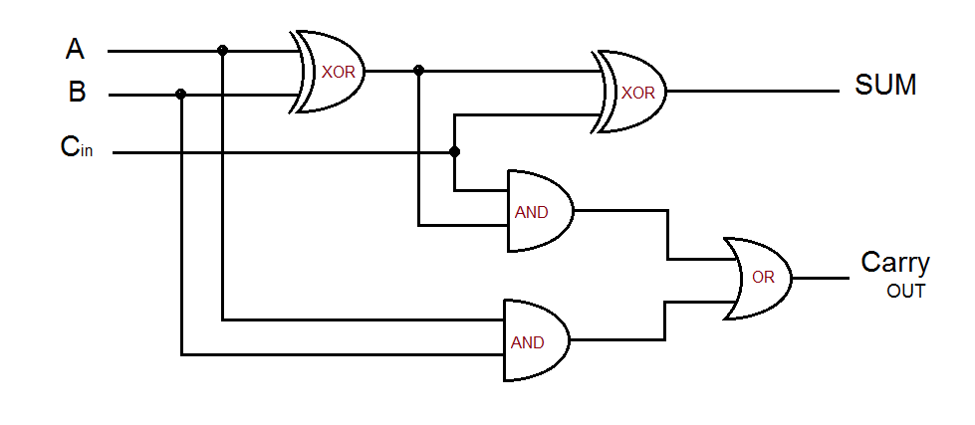
Figure 1: Full-Adder Logic Diagram

A 4-bit adder is constructed by cascading four of these single-bit full adders. The carry output of each stage becomes the carry input of the next higher-order bit. This creates a structure known as a ripple-carry adder, where the carry “ripples” from the least significant bit (LSB) to the most significant bit (MSB). Although simple and reliable, this design introduces propagation delay because each stage must wait for the preceding carry to settle.
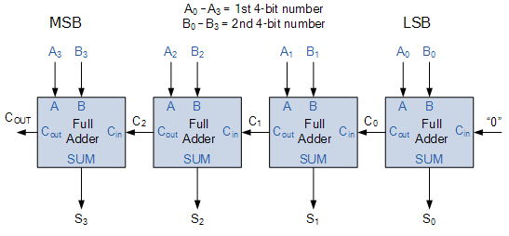
Figure 2: 4-bit Ripple-Carry Adder Block Diagram

1.3.1 IC 7483 AS A 4-BIT RIPPLE-CARRY ADDER
The IC 7483 is a TTL 4-bit binary full-adder IC that internally implements this ripple-carry architecture. It accepts two 4-bit inputs (A3–A0 and B3–B0) and a carry-in (C0), and produces a 4-bit binary sum (S3–S0) and a carry-out (C4). The device is widely used in arithmetic circuits due to its compactness, predictable behavior, and compatibility with standard TTL logic levels.
Pin-Level Operation
- Inputs:
  - A0–A3 (lower to higher bits of operand A)
  - B0–B3 (lower to higher bits of operand B)
  - C0 (initial carry input)
- Outputs:
  - S0–S3 (sum bits)
  - C4 (final carry output)
Internally, the IC connects four full adder stages in series. The carry generated by each stage propagates to the next, making the final carry-out dependent on all previous stages. Because of this, the IC 7483 behaves exactly as a 4-bit ripple-carry adder, not a carry look-ahead adder.
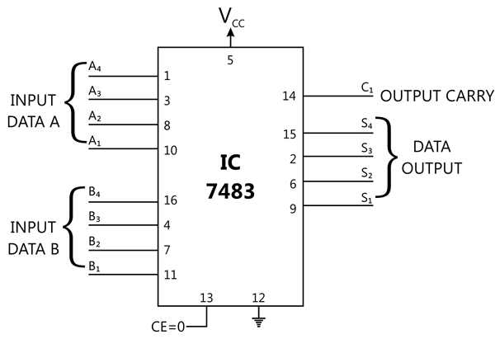
Figure 3: IC 7483 Pinouts

1.4 BCD TO 7-SEGMENT DECODER THEORY
Before getting into details of the working principle lets see the pin diagram of 7-Segment Display also as we are using common anode display the inverted logic has to be given to the display, so we have included it in the decoder itself.
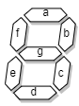
Figure 4: 7-Segment Display Segment and Pin Assignments

As we are using customized BCD to 7-Segment Decoder the output looks like the below 7-Segment Display
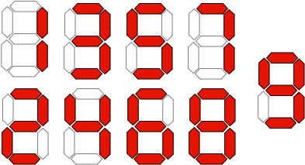
Figure 5: BCD-to-7-Segment Decoder Output for Digits 0-9

A 7-segment display has seven LEDs (segments a–g) arranged to show digits 0-9. A BCD-to-7-segment decoder converts a 4-bit BCD input into the correct 7-bit pattern that lights the required segments. Each valid BCD code (0000–1001) maps to a fixed segment combination.
Table 2: Truth Table for BCD-to-7-Segment Decoder
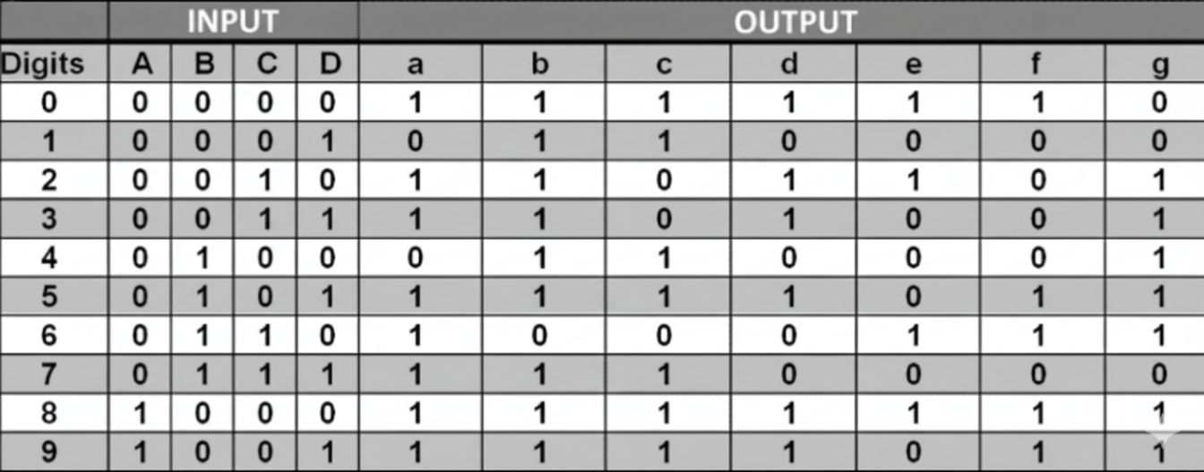

Seven-segment modules come in common cathode (CC) and common anode (CA) types.
- Common Cathode: Cathodes tied to ground; a segment turns ON with a logic HIGH.
- Common Anode: Anodes tied to Vcc; a segment turns ON with a logic LOW.
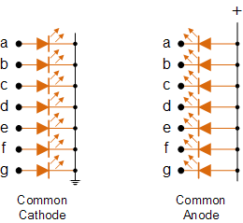

Figure 6: Internal LED Schematic Comparison of Common Cathode and Common Anode 7-Segment Displays

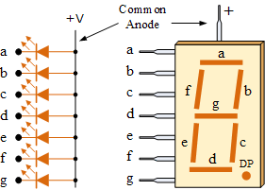
Figure 7: Circuit Diagram of Common Anode 7-Segment Display Connection

Decoder logic must match the display type. CA displays require inverted outputs, which can be done either with NOT gates or by integrating inversion directly into the Boolean expressions for segments a-g.
Each segment output is defined by a minimized Boolean expression derived from the BCD-to-segment truth table (using K-maps or direct minimization). For example, a typical expression for segment a (CC type) is built from the input combinations for which a must light. Similar minimized expressions are produced for the remaining segments.
1.4.1 BCD TO 7 SEGMENT DECODER USING IC 7447
The IC 7447 is a BCD-to-7-segment decoder/driver used to display decimal digits on a 7-segment LED display. It converts a 4-bit Binary Coded Decimal (BCD) input (0–9) into signals that drive the display segments (a–g), simplifying the interface between digital logic and the LED display (Jotrin, n.d.).
Key Features:
- Inputs: 4-bit BCD (A, B, C, D)
- Outputs: 7 segments (a–g), active-low, for common-anode displays
- Control pins: Lamp Test (LT), Blanking Input (BI), Ripple Blanking Input/Output (RBI/RBO)
- Supply voltage: 5 V
Operation:
- For valid BCD inputs (0000₂–1001₂), IC 7447 activates the corresponding segments to display digits 0–9.
- Outputs are undefined for invalid BCD inputs (1010₂–1111₂).
- Current-limiting resistors (~330 Ω) are recommended between outputs and LED segments.
Advantages:
- Reduces required I/O lines or logic gates.
- Built-in features (LT, BI/RBO) allow easy testing and suppression of leading zeros.
- Ideal for use with a 4-bit BCD adder to directly display the sum on a 7-segment display.
1.5 DUAL DISPLAY OUTPUT CONFIGURATION
Adding two BCD digits (0–9) produces results from 0 to 18. Since a single 7-segment display can only show 0–9, two displays are required:
- Tens digit: 0 or 1
- Units digit: 0–9
The 4-bit BCD adder produces S3-S0 plus a carry-out C4, giving a 5-bit result. For sums 0-9, C4 = 0 and S3–S0 already form valid BCD. For sums 10-18, the raw binary result is invalid in BCD, so the adder applies the standard +6 correction (because sum > 9 or carry occurred).
Example. 9 + 6 = 15:
- 1001 + 0110 = 1111 → invalid BCD
- 1111 + 0110 = 10101
- C4 = 1 → tens digit = 1
- Lower 4 bits = 0101 → units digit = 5
Thus:
- Tens display: driven directly by C4 (only shows “0” or “1”).
- Units display: driven by the corrected 4-bit sum.
The overall system performs:
- 4-bit BCD addition
- Detection of sum > 9 or carry
- +6 correction
- Splitting into tens (C4) and units (corrected S3–S0)
- Driving two independent 7-segment displays
This ensures correct decimal output for every sum from 0 to 18.
1.6 CONCEPTUAL SYSTEM ARCHITECTURE
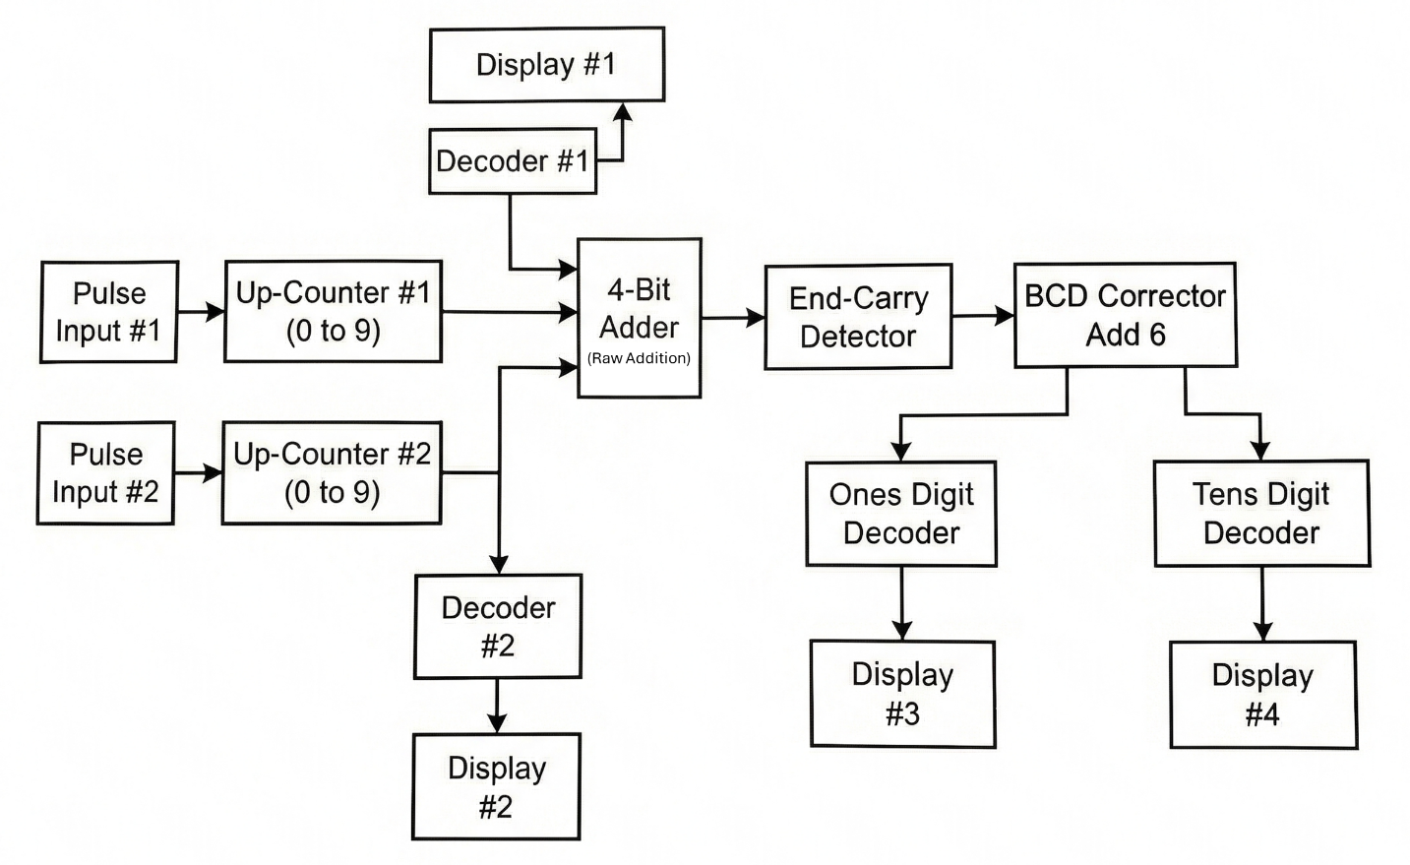
Figure 8:BCD Adder System Block Diagram

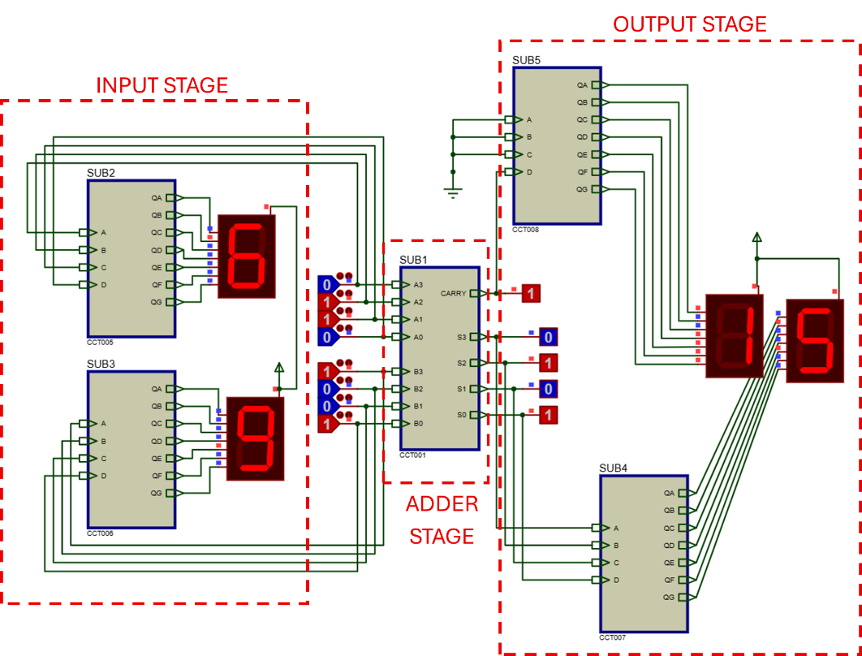
Figure 9: Conceptual System Circuit Architecture

To understand the overall operation of the BCD adder, it is useful to begin with the high-level block diagram that represents the logical flow of signals through the system. This conceptual diagram divides the circuit into three major functional sections:
- Input Stage – where each decimal digit (Addend 1 and Addend 2) is generated and displayed
- Adder Stage – where binary addition and BCD correction occur
- Output Stage – where the resulting tens and units (ones) digits are displayed
This diagram presents each functional stage as a single block for clarity. Although this simplified representation is sufficient for understanding the theoretical operation, it does not fully reflect how the system is physically implemented using multiple integrated circuits.
In practice, each block is expanded into several ICs used to support BCD digit generation, binary addition, correction logic, and display decoding. The actual circuit therefore requires additional hardware such as:
- Two IC 7493 ripple counters for digit generation
- Two IC 7447 decoders for input displays
- Two IC 7483 full adders (one for raw addition, one for BCD correction)
- AND and OR gates for correction detection
- Two IC 7447 decoders for final output displays
Thus, while the conceptual architecture provides the theoretical framework, Section 2.0 presents a stage-by-stage breakdown of how the system was realized in hardware, including the complete schematic and the corresponding implementation for each subsystem.
2.0 SCHEMATIC DIAGRAM AND SYSTEM IMPLEMENTATION
This section presents the full schematic of the BCD adder and a detailed explanation of each subsystem. The complete circuit is composed of five major stages:
- Addend 1 Input Stage (with Display)
- Addend 2 Input Stage (with Display)
- 4-Bit Adder (Raw Addition Stage)
- BCD Correction Logic (Detector and Corrector)
- Final Output Display Stage (Tens and Ones Digit)
Each stage is discussed in detail below.
2.1 ADDEND 1 INPUT STAGE (WITH DISPLAY)
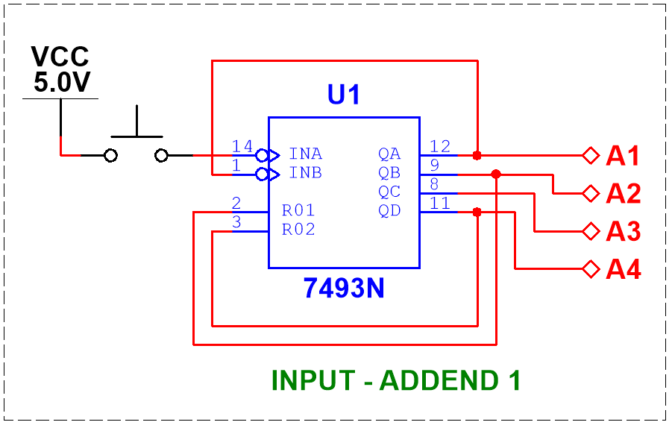
Figure 10: Addend 1 Input Circuit

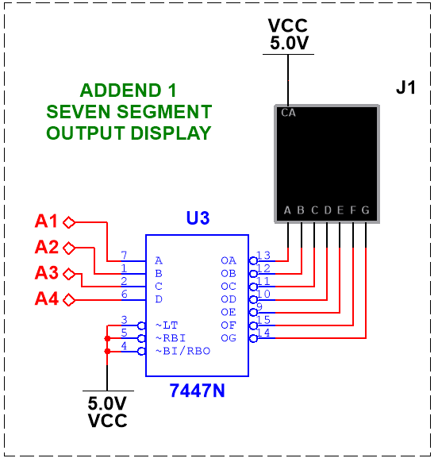
Figure 11: Addend 1 Output 7-Segment Display Circuit

The Addend 1 stage is responsible for generating the first BCD input digit. It consists of:
- IC 7493 (U1) – A 4-bit binary ripple counter used to cycle through values 0000–1001 (0–9)
- IC 7447 (U3) – A BCD-to-7-segment decoder that drives the input display
- 7-Segment Display Module (J1) – Shows the current value of Addend 1
Operation
- A push-button or clock pulse increments the 7493 counter.
- The counter outputs a 4-bit binary number (Q0–Q3).
- These lines feed directly into the 7447 decoder IC.
- The 7447 converts the BCD code into the appropriate active-low segment signals for the common-anode display.
- The 7-segment display shows the digit selected as Addend 1.
Signal Flow
- Counter → BCD output → Decoder → Display → Sent to Adder Stage (U5)
- The output of U1 (Addend 1) is forwarded to the primary adder (IC 7483 U5), where addition begins.
2.2 ADDEND 2 INPUT STAGE (WITH DISPLAY)
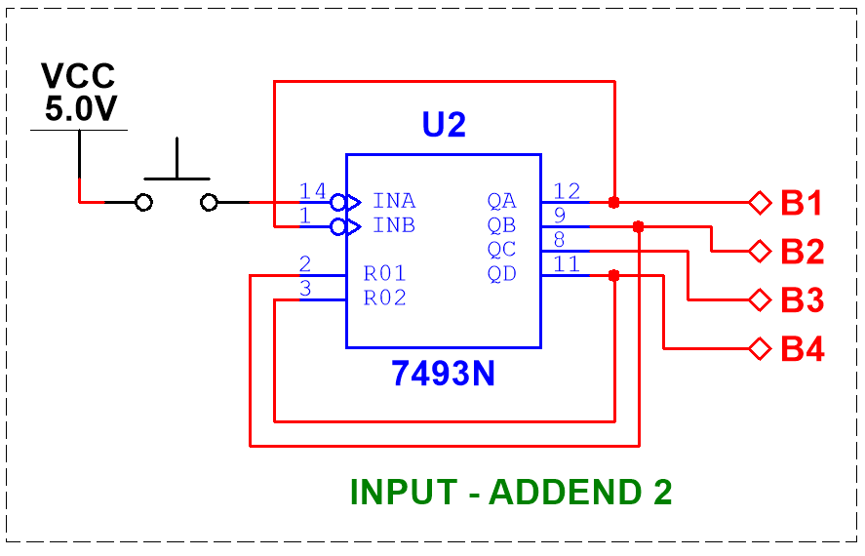
Figure 12: Addend 2 Input Circuit

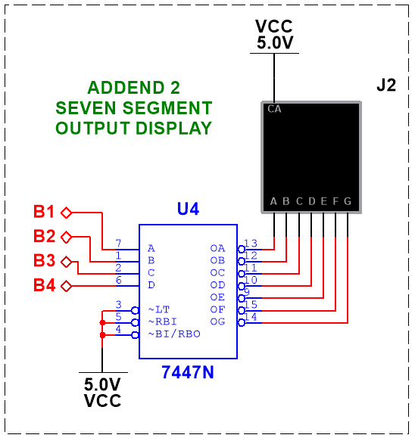
Figure 13: Addend 2 Output 7-Segment Display Circuit

This stage is identical in function to Addend 1 but generates the second BCD digit. It uses:
- IC 7493 (U2) – Counter for Addend 2
- IC 7447 (U4) – Decoder for displaying Addend 2
- 7-Segment Display (J2) – Visual output of Addend 2
Operation
- Addend 2 is adjusted the same way as Addend 1, using count pulses to cycle through 0–9. The resulting BCD code is decoded via 7447 and displayed through its own 7-segment module.
Signal Flow
- Counter → Decoder → Display → Sent to Adder Stage (U5)
- The outputs of U2 flow into the other 4-bit operand input of the 7483 binary adder.
2.3 RAW BINARY ADDITION STAGE (4-BIT ADDER)
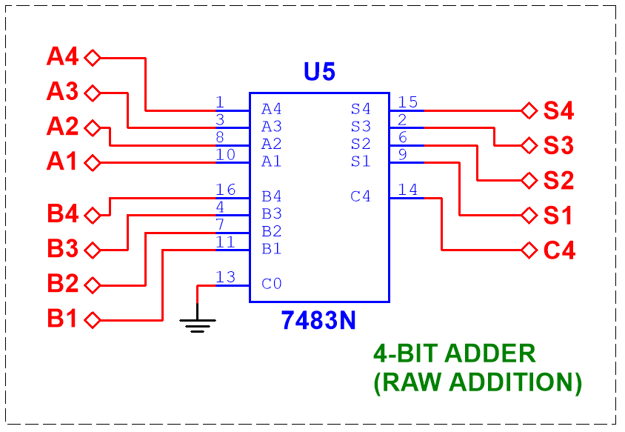
Figure 14: 4-Bit Adder (Raw Addition) Circuit

Raw addition is performed by:
- IC 7483 (U5) – 4-bit binary full adder
Operation
- U5 accepts two 4-bit operands:
  - A3–A0 from Addend 1 (U1)
  - B3–B0 from Addend 2 (U2)
- The carry-in pin (C0) is tied to logic LOW (0).
- U5 produces:
  - Raw Sum (S3–S0)
  - Carry Out (C4)
This output may or may not be valid BCD, depending on whether the binary sum exceeds 9.
2.4 BCD CORRECTION STAGE (DETECTOR AND CORRECTOR)
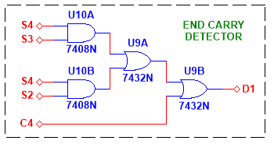
Figure 15: End-Carry Detector Circuit

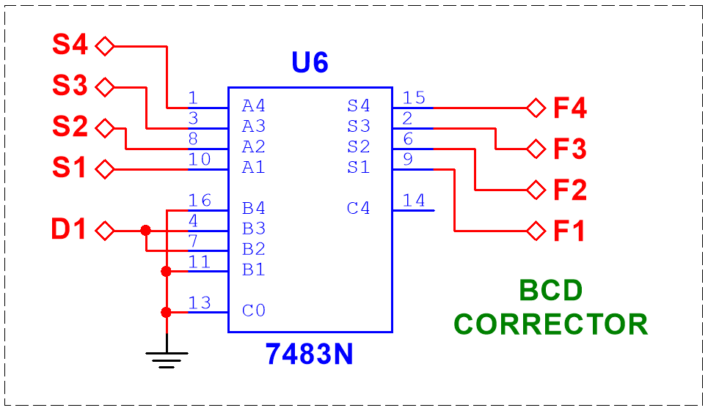
Figure 16: BCD Corrector Circuit

This section ensures that the raw binary sum from U5 is corrected to valid BCD before display.
Components:
- IC 7408 (U10) – AND gates
- IC 7432 (U9) – OR gates
- IC 7483 (U6) – Secondary 4-bit adder for adding correction value (0110)
Correction Logic
BCD correction is required when:
- The raw sum > 9 (binary 1010–1111), or
- The raw adder produces a carry (C4 = 1)
The detection circuit generates the signal ADD6, which becomes HIGH when correction is needed.
Correction Process
When ADD6 = 1:
- The second 7483 adder (U6) adds 0110 (decimal 6) to the raw sum
- This converts invalid BCD into correct BCD
Outputs from U6 become:
- Units digit (BCD)
- Tens carry (to tens display)
Raw Sum → BCD Correction → Corrected Sum + Tens Carry
Derivation of the BCD Correction Logic
The carry-over detector plays a critical role in ensuring that a BCD adder produces valid decimal outputs. In BCD representation, each digit must stay within the range 0000 to 1001 (0–9). When a binary adder produces a result greater than 9, the value is no longer a valid BCD digit and must be corrected.
The purpose of deriving the Boolean function in this experiment is to design a circuit that can automatically identify when this situation occurs. By analyzing the output bits of the adder, the carry-over detector determines whether the sum represents a value from 10 to 15 or whether a carry into the next digit has occurred. If any of these conditions are true, the detector outputs a logic high, indicating that the adder has produced an invalid BCD result and that the correction logic (by adding 6) must be applied.
This ensures that the final output remains within the valid BCD range and allows the multi-digit addition system to operate properly. The derivation therefore provides the exact Boolean expression needed to implement this detection using logic gates, making the adder accurate and compliant with BCD rules.
Table 3: Truth Table of the End-Carry Detector Circuit
Index | C₄ | S₄ | S₃ | S₂ | S₁ | D₁
0 | 0 | 0 | 0 | 0 | 0 | 0
1 | 0 | 0 | 0 | 0 | 1 | 0
2 | 0 | 0 | 0 | 1 | 0 | 0
3 | 0 | 0 | 0 | 1 | 1 | 0
4 | 0 | 0 | 1 | 0 | 0 | 0
5 | 0 | 0 | 1 | 0 | 1 | 0
6 | 0 | 0 | 1 | 1 | 0 | 0
7 | 0 | 0 | 1 | 1 | 1 | 0
8 | 0 | 1 | 0 | 0 | 0 | 0
9 | 0 | 1 | 0 | 0 | 1 | 0
10 | 0 | 1 | 0 | 1 | 0 | 1
11 | 0 | 1 | 0 | 1 | 1 | 1
12 | 0 | 1 | 1 | 0 | 0 | 1
13 | 0 | 1 | 1 | 0 | 1 | 1
14 | 0 | 1 | 1 | 1 | 0 | 1
15 | 0 | 1 | 1 | 1 | 1 | 1
16 | 1 | 0 | 0 | 0 | 0 | 1
17 | 1 | 0 | 0 | 0 | 1 | 1
18 | 1 | 0 | 0 | 1 | 0 | 1
19-31 | Don’t Care Condition

$$D1=\sum{(10, 11, 12, 13, 14, 15, 16, 17, 18)}$$
$$Dont Care= \sum{(19, 20, 21, 22, 23, 24, 25, 26, 27, 28, 29, 30, 31)}$$
K-mapping:
- Let C₄ = A, S₄ = B, S₃ = C, S₂ = D, S₁ = E
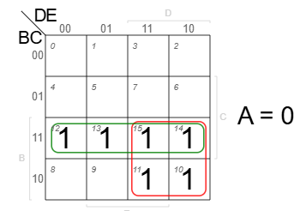 | 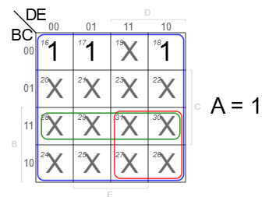
Figure 17: K-mapping Truth Table of Table 3

- D₁ = A + BD + BC
- D₁ = C₄ + S₄S₂ + S₄S₃
2.5 OUTPUT DISPLAY STAGE
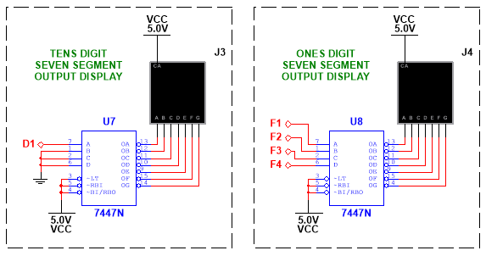
Figure 18: Ones and Tens Digit 7-Segment Output Display CIrcuits

This stage displays the final decimal result using two separate outputs:
- Units Digit Display – shows 0–9
- Tens Digit Display – shows 0 or 1
Components used:
- IC 7447 (U7) – Units BCD-to-7-segment decoder
- IC 7447 (U8) – Tens decoder
- 7-Segment Displays (J3 and J4)
Operation
- Units (Ones) Digit
- Receives corrected BCD from U6 (Correction Adder)
- Decoder U7 drives display J4
- Tens Digit
- Receives the final carry from U6
- Tens BCD is either 0000 or 0001
- Decoder U8 drives display J3
This ensures the final displayed output is the correct sum from 0 to 18.
2.6 COMPLETE CIRCUIT SCHEMATIC
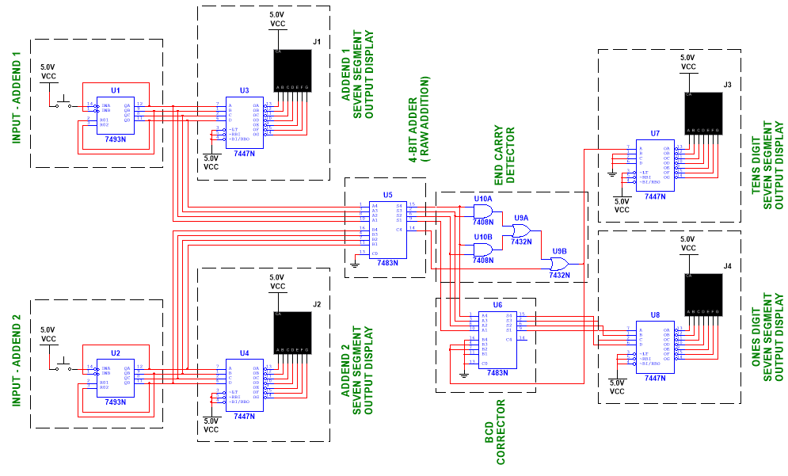
Figure 19: Full System-Level Schematic of the BCD Adder with Seven-Segment Input and Output Displays

This figure combines all stages into one integrated system. It shows:
- The routing of BCD signals from inputs to adders
- The correction logic and carry detection
- All decoder ICs and their corresponding displays
- Inter-stage wiring and power connections
This schematic represents the complete and final hardware implementation of the BCD adder.
Summary of Components
Table 3: Component List of the Schematic Diagrams of Figure 11-13.
Component | Reference Designator | Specification
IC 7493 | U1, U2 | 4-bit binary ripple counter
IC 7483 | U5, U6 | 4-bit binary full adder
IC 7447 | U3, U4, U7, U8 | BCD to 7-segment decoder/driver
IC 7432 | U9 | quad 2-input OR gate
IC 7408 | U10 | quad 2-input AND gate
Push Button | SW1, SW2 | SPST Switch
Pin Header | J1, J2, J3, J4 | 9-Pin Straight Through Male Header
Screw Terminal | J5 | 2-Pin Screw Terminal
Complete List of Required Materials

- 1x PCB (14 cm × 8 cm)
- 4x 14-pin IC sockets
- 6x 16-pin IC sockets
- 4x 7447 ICs
- 2x 7493 ICs
- 2x 7483 ICs
- 1x 7408 IC
- 1x 7432 IC
- 4x Common-anode 7-segment displays
- 2x JST 2-pin connectors, 2.5 mm pitch (male + female pairs)
- 4x 9-pin straight male headers
- 2x Push buttons
- 1x 2-pin screw terminal

3.0 PCB DESIGN
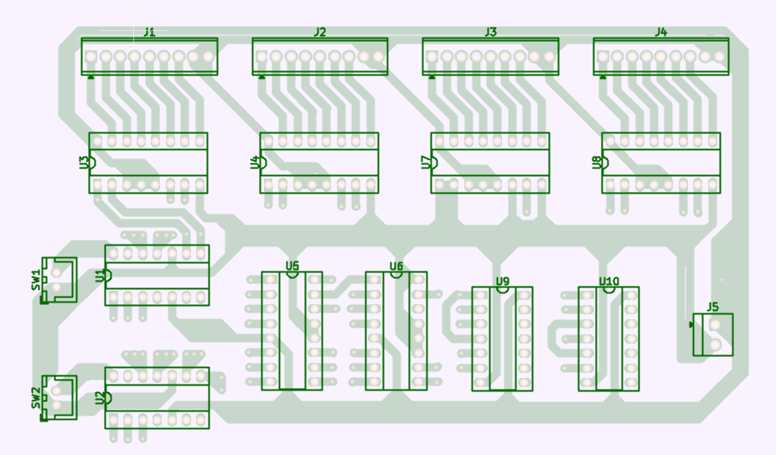
Figure 20: Single-Sided PCB Layout of the Circuit

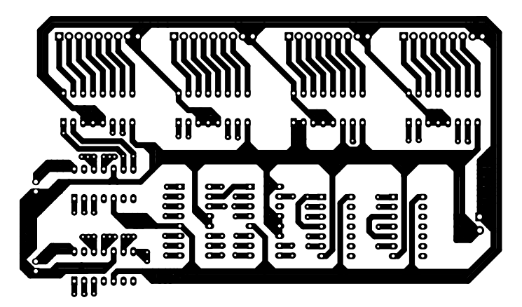
Figure 21: Copper Layer Trace of the Single-Sided PCB

4.0 CIRCUIT PROTOTYPE
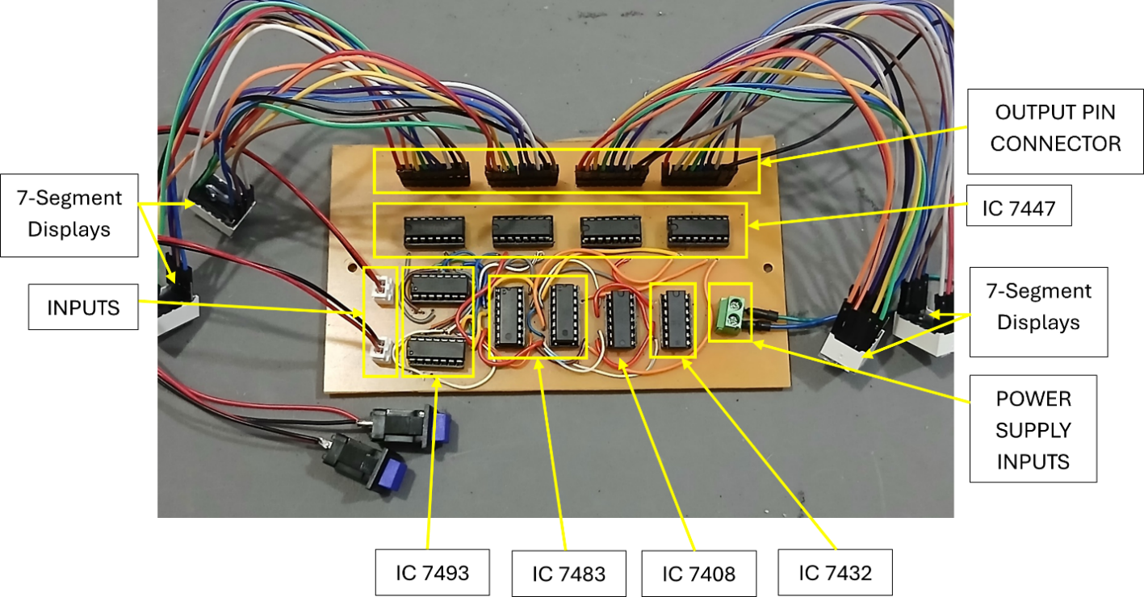
Figure 22: Completed Prototype of the Circuit on PCB

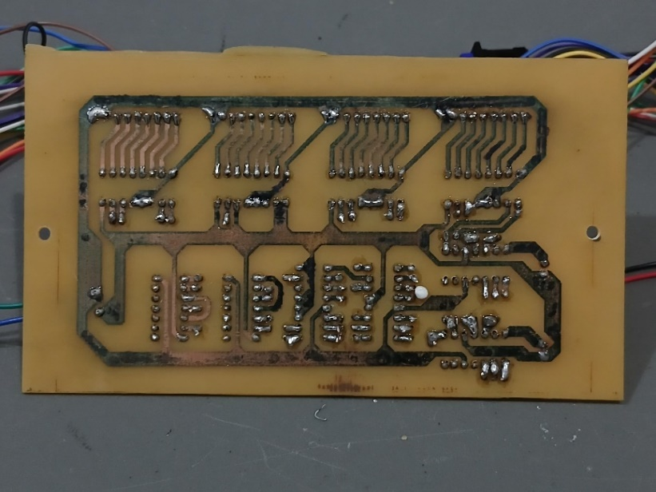
Figure 23: Etched and Soldered Single-Sided PCB

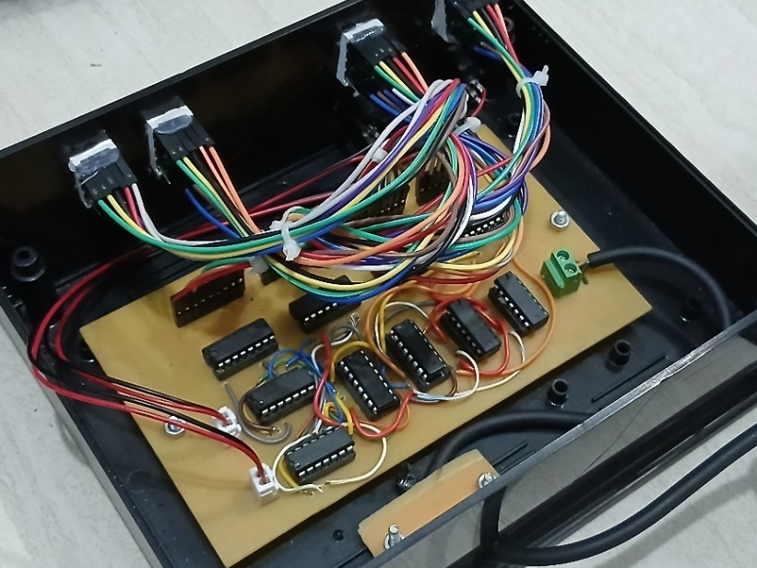
Figure 24: Final Circuit Prototype Encased in Housing

5.0 TESTING AND ANALYSIS
Initial testing revealed several unexpected behaviors in the prototype. The 7-segment displays were showing incorrect digits, and the push-button inputs did not cycle through values properly. In particular, the input appeared to toggle only between 0 and 7, and the system produced correct sums only when the input happened to settle on 7. When the input returned to 0, the displayed output became unstable or glitched.
During this phase, the power module’s voltage regulator IC was observed to be extremely hot, indicating that it could not supply sufficient current for the entire circuit. We concluded that the unstable input and incorrect display outputs were symptoms of power starvation and voltage drop under load.
To address this, the initial power module was bypassed. A 5 V, 2 A USB–Type-C charger was cut open, and its positive and ground wires were directly connected to the circuit’s power rails. This provided a stable 5 V supply with adequate current. After switching to this supply, the circuit immediately produced correct outputs, the displays updated properly, and the adder performed all operations from 0 + 0 to 9 + 9 without errors.
However, after repeated testing, new problems emerged. Individual LED segments began to dim, flicker, and eventually fail completely. Over time, more segments died until the displays no longer illuminated at all. Upon reviewing the wiring, we discovered the root cause: the circuit had been powered without any current-limiting resistors on the 7-segment display outputs.
Since each segment is an LED, it requires a resistor (typically 220–330 Ω) to limit current. Without these resistors, the segments were exposed to excessive current directly from the logic IC outputs, causing thermal overstress and permanent LED damage. This explains why segments failed progressively—the LEDs degraded one by one until the display was unusable.
In summary:
- Initial malfunction was caused by insufficient current from the original power regulator.
- Correct operation was achieved with a stable 5 V, 2 A external supply.
- Final display failure resulted from missing current-limiting resistors, leading to LED burnout.
This testing stage highlights the importance of proper power regulation and protective components when interfacing digital logic with LED-based display hardware.
6.0 CONCLUSION
This project successfully demonstrated the design, implementation, and testing of a fully display-integrated BCD adder capable of adding two single-digit decimal numbers (0-9) with complete visual input and output through 7-segment displays. The system effectively bridges human-readable decimal arithmetic with digital logic circuits, providing an intuitive interface for binary coded decimal operations.
6.1 KEY ACHIEVEMENTS
The completed circuit integrates several critical components into a cohesive system: a 4-bit full adder with fast carry propagation, custom BCD to 7-segment decoders, and dual output displays for handling results from 0 to 18. Unlike conventional implementations using standard IC7447 decoders that produce undefined outputs for invalid BCD inputs, our custom decoder incorporates error detection logic that displays "E" when inputs exceed the valid 0-9 range. This enhancement significantly improves user experience and circuit reliability by providing immediate feedback on invalid operations.
The theoretical foundation established through BCD arithmetic principles, combined with practical implementation considerations such as common anode display requirements and inverted logic, proved essential in achieving a fully functional prototype. The use of latched logic state sources at the inputs allowed for stable operation and easy manipulation of input values during testing.
6.2 TECHNICAL INSIGHTS
Through the development process, several important insights emerged. The necessity of the BCD correction factor (adding 6 when the sum exceeds 9) became evident in both theoretical analysis and practical testing. The implementation of fast carry logic reduced propagation delays, ensuring responsive operation across all input combinations. The decision to employ custom decoder circuitry rather than standard ICs demonstrated the value of tailored solutions in addressing specific design requirements, particularly in error handling and display clarity.
The two-display output configuration effectively separates tens and units digits, utilizing the carry-out signal to drive the tens display while the lower four sum bits control the units display. This approach provides clear, unambiguous output representation for all possible sums from 0 to 18.
6.3 PRACTICAL APPLICATIONS AND EDUCATIONAL VALUE
This project holds significant educational value in demonstrating fundamental digital logic concepts including combinational circuit design, BCD arithmetic, decoder implementation, and practical considerations in interfacing logic circuits with display devices. The visual nature of the 7-segment displays makes the circuit's operation immediately comprehensible, making it an excellent teaching tool for digital electronics laboratories.
Beyond its educational applications, the principles demonstrated in this BCD adder are foundational to more complex digital systems such as calculators, digital clocks, counters, and any application requiring decimal arithmetic operations with visual display output.
6.4 FUTURE ENHANCEMENTS / RECOMMENDATIONS
While the current implementation successfully meets all project objectives, several enhancements could further improve functionality, reliability, and applicability of the system. One important improvement is the incorporation of a debouncer circuit for the push-button inputs. Since mechanical switches inherently produce contact bounce, the absence of a debouncing mechanism can cause unintended multiple counts or unstable input transitions. Implementing either an RC debouncer, Schmitt-trigger conditioning, or a dedicated debouncer IC would ensure clean, noise-free input pulses and significantly improve the accuracy and responsiveness of the input stages.
6.5 FINAL REMARKS
The successful completion of this fully display-integrated BCD adder demonstrates mastery of essential digital logic design principles from theoretical foundation through practical implementation. The project validates the importance of comprehensive testing, careful component selection, and attention to user interface considerations in creating functional and reliable digital circuits. The knowledge and experience gained through this project provide a strong foundation for more advanced digital system design endeavors.
7.0 REFERENCES
[1] CHENCHETY-ABHISHEK. (n.d.). 4-Bit BCD Adder using 7-Segment Display
[Computer software]. GitHub. https://github.com/CHENCHETY-ABHISHEK/4-
Bit-BCD-ADDER-USING-7-SEGMENT-DISPLAY/tree/main
[2] ElectricalTechnology.org. (2018, May). BCD to 7-segment display decoder.
Electrical Technology. https://www.electricaltechnology.org/2018/05/bcd-to-7-
segment-display-decoder.html
[3] Electronics-Tutorials.ws. (n.d.). Combination logic – BCD to decimal and 7-segment
display. Electronics-Tutorials.ws. https://www.electronics-tutorials.ws/
combination/comb_6.html
[4] Electronics-Tutorials.ws. (n.d.). 7-segment display tutorial. Electronics-Tutorials.ws.
https://www.electronics-tutorials.ws/blog/7-segment-display-tutorial.html
[5] Jotrin.com. (n.d.). IC 7447 – BCD to 7-segment decoder/driver. Jotrin Electronics
Market. https://www.jotrin.com/technology/details/ic-7447?srsltid=AfmBOorA8
_iL9cZ5LLzmkaSTN13NDEajyYGgwSbez84bUIovc8dm2LkE

